Item: SSM-280(220V/60HZ/1PH)

<Issue>
One unit doesn’t freeze or cool. The compressor is getting hot

<Check points>
Our machine’s compressor is designed to start 3 minutes later after you turn on the machine.
In order to analyze the issue and find solution, please kindly check the following points one by one.

1. Cranking sound of solenoid valve (Sounds like a ‘click’)
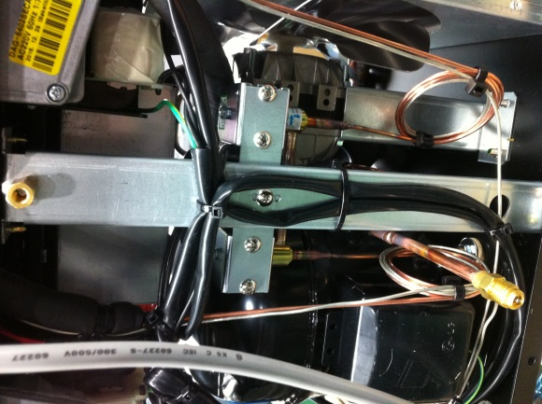
Solenoid valves(circled in red) begin supplying refrigerants after three minutes since switch-on. Please check if you can hear the cranking sound (sounds like a ‘click’)

2. Fan motor
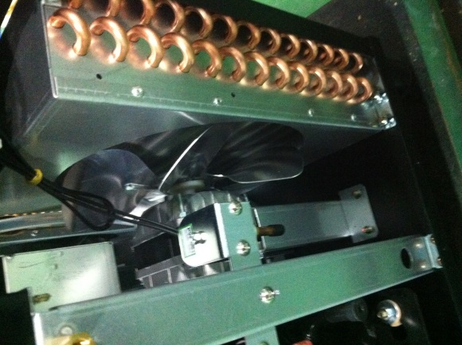
Please check if fan is running when the compressor is working.
Fan motor issues can be the reason the compressor is getting hot.
Once compressor becomes hot because cooling doesn’t work, high-pressure starts working to protect compressor. So it looks like machine doesn’t freeze or cool

3. Compressor accessories - Starting capacitor
Compressor is initiated by the starting capacitor.
Please check if the capacitor is supplying current to compressor
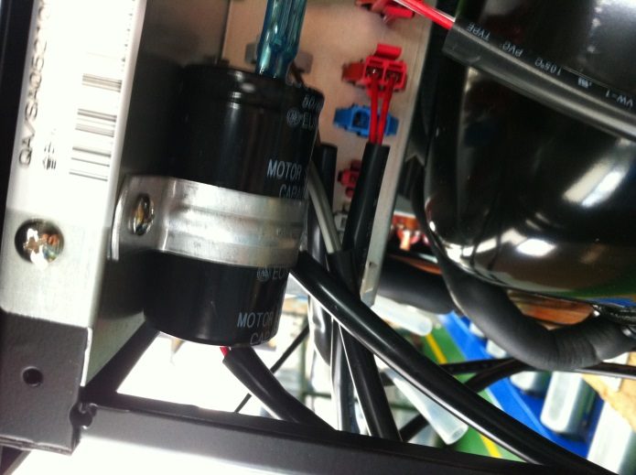

4. Frost check on drum
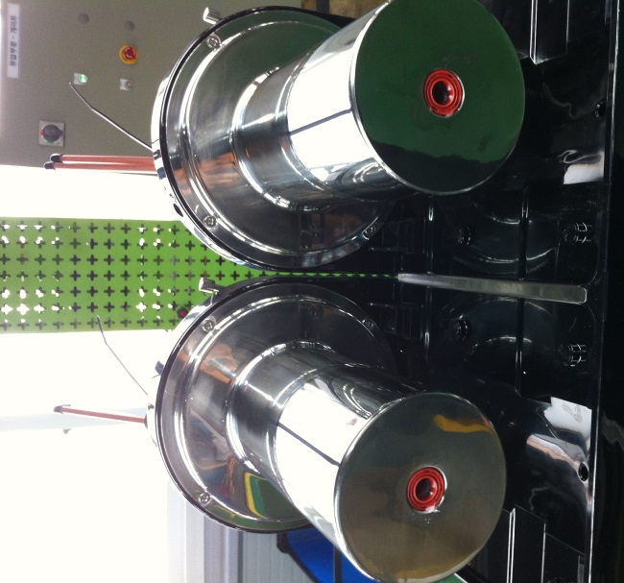
Please remove canister and put water around drum after three minutes from switch-on.
Please check if frost appears evenly around drums ( frost on drums around 360°)

